MATLAB Setup Solutions

Assigned: 29 August 2016

# Rubric

+3 Pts if they posted a screenshot AND their profile picture is their face

+2 Pts if they posted a screenshot, no profile pic

+1 Pts if profile pic, no screenshot

# Assignment

For the first half of the class we will use MATLAB online. This way you can access it from anywhere with an internet connection. If you would prefer to download and install the desktop software to your computer, go for it! In fact, I think you *should* but this is the easiest way to implement MATLAB to a whole class.

# To get MATLAB online…

Follow the instructions available at:  
<http://www.coetech.marquette.edu/index.php/2016/04/27/introducing-matlab-online/>

# After you follow those instructions…

Log into the system and make sure that you can access the MATLAB command area. It should look something similar to this. If you truly want to replicate this screenshot you are going to have to open a new tab and make a Pandora playlist with… on second thought, I’ll keep that a secret.

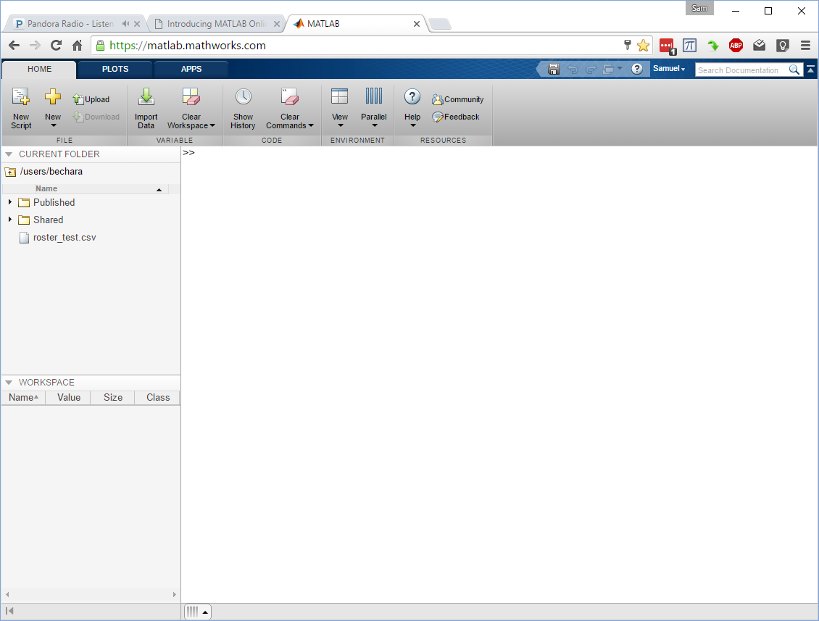

That’s it! You are almost done. Now take a screenshot, like the one above and upload it to the appropriate dropbox folder on D2L. If you don't know how to take a screenshot, google will help.

Face Setup

Don't forget, you HAVE to upload a picture of your face to your D2L profile. This is to help me to get to know you better. Uploading a picture of your face to D2L is not optional and will be a part of your grade.

Sorry, not all of the HW assignments are going to be this easy.